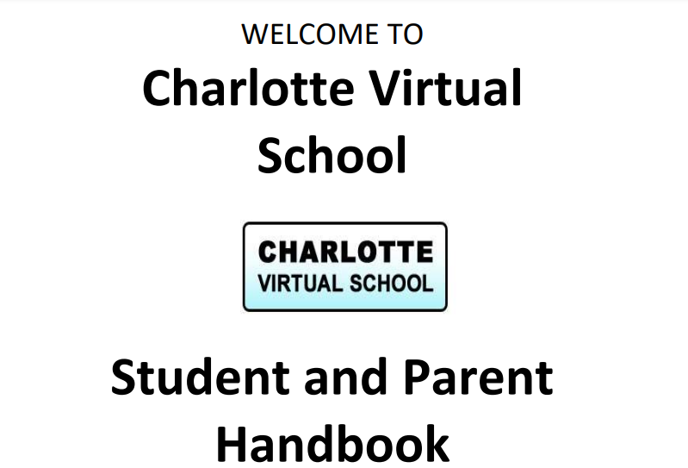

2022-2023 currently being updated

Email: [Leanne.Fahey@yourcharlotteschools.net](mailto:Leanne.Fahey@yourcharlotteschools.net)

Address: 18150 Murdock Cir

Port Charlotte, FL 33948

Phone: 941-255-7507

[www.yourcharlotteschools.net/cvs](http://www.yourcharlotteschools.net/cvs)